**Project Requirements Specification**



**School Of Computer Application**

**Session: 2017-18**

Software Requirement Specification

For

**FleetoMoto Management System**

(Web)

Master of Computer Applications

Of

Lovely professional university, Punjab

**Submitted By:**

Amit Kumar Sharma Yaskaran Pallvi Pooja Pratap

11612374 11601135 11612003 11617053 11508735

**Submitted To:**

Department of Computer Applications

Lovely Professional University, Punjab

**Project Requirements Specification**

**Table Of Contents**

1. EXECUTIVE SUMMARY……………………………………………………………………………………….……………..……...3

1.1 PROJECT OVERVIEW……………………………………………………………………………………………………….….3

1.2 PURPOSE AND SCOPE OF THIS SPECIFICATION……………………………………………………………….….3

2. PRODUCT/SERVICE DESCRIPTION………………………………………………………………………………………………..3

2.1 USER CHARACTERISTICS………………………………………………………………………………………………………4

2.2 ASSUMPTIONS……………………………………………………………………………………………………………………5

2.3 CONSTRAINTS…………………………………………………………………………………………………………………….5

2.4 DEPENDENCIES…………………………………………………………………………………………………………………..5

3. REQUIREMENTS……………………………………………………………………………………………………………………….5-7

3.1 FUNCTIONAL REQUIREMENTS.……………………………………………………………………………………..7-10

3.2 USER INTERFACE REQUIREMENS……………………………………………………………………………………..10

3.3 USABILITY………………………………………………………………………………………………………………………..10

3.4 PERFORMANCE………………………………………………………………………………………………………………..11

3.4.1 CAPACITY………………………………………………………………………………………………………………...11

3.4.2 AVAILABILITY……………………………………………………………………………………………………………11

3.4.3 LATENCY…………………………………………………………………………………………………………………..11

3.5 MANAGEMENT /MAINTAINABILITY………………………………………………………………………………….11

3.5.1 MONIO TORING………………………………………………………………………………………………………..11

3.5.2 MAINTENANCE…………………………………………………………………………………………………………11

3.5.3 OPERATIONS…………………………………………………………………………………………………………….12

3.6 SYSTEM INTERFACE/INTEGRATION……………………………………………………………………………………12

3.7 SECURITY…………………………………………………………………………………………………………………………..12

3.7.1 PROTECTION……………………………………………………………………………………………………………..12

3.7.2 AUTHORIZATION AND AUTHENTICATION……………………………………………………………….…12

3.8 DATA MANAGEMENT……………………………………………………………………………………………………….12

4 . USER SCENARIOAS/USE CASES……………………………………………………………………………………………………….13

5. DELETED OR DEFERRED REQUIREMENTS………………………………………………………………………………………13

APPENDIX A. REFERENCES…………………………………………………………………………………………………13

APPENDIX B. REQUIREMENTS TRACEBILITY MATRIX………………………………………………………….13

**Project Requirements Specification**

**1. Executive Summary**

**1.1** **Project Overview**

Our project “FleetoMoto Management System” is an initiative to provide a platform that promotes interconnectivity between trader, distributor, admin, tele caller and client. The OBC Connector will provide different module like Distributor, admin, Dealer, Accounts, tele Caller, operational Executive with different functionality.

The need of this project arises when the admin has to make record of all product separately on the excel sheet. When the admin sells and give his product to the distributor who are in other city or state he has to write record manually that this many products he is giving to this distributor and these many to others. Other side distributors also have its dealer who sells product to clients. Now it is not a difficulty for admin to make record of all product but also distributor face some trouble of keeping all record which he has to give to admin.

Here the problem does not end. Now admins have also face difficulties related to collect money from distributors. They want some automation in their business that show them that these distributors do not give him money and other side distributors also want to see how many products they have sold and how many they left with.

The OBC Connector System has five active actors. The Admin, Distributor, Dealer, tele caller, and operation executive.

Admin

The Admins can access all data like check collected money, accrued income, number of distributor, product given to distributor and active product.

Distributor

The Distributors can check that how many dealers they have, who paid money, how much they receive money, number of sells product and balance.

Dealer

The Dealers has limited access. They only check certain values. Like money paid, product sold, remaining balance.

Tele Caller

The tele caller call and send message to those whose money is due or whose subscription pack is going to be finished.

Accounts

The accounts check the detail of payments, add bank information, retrieve data and send notification related to the payments to the distributors.

**1.2** **Purpose and Scope of this Specification**

The purpose of our project is to provide platform that promotes interconnectivity between the admin, distributor, dealer, operation executives and accounts. The admin face problem to remember all balance and receive amount that how much distributor paid and how many do not pay. After remembering all these in excel sheet they have to make excel sheet which is complicated task for the admins. To remove these problem OBC connector is developed.

This website is made with the help many scripting languages. Like html, css, Angular js, PHP, MySQL etc. The software is mobile Responsive also. So, that it can be easily use by the client. As we know, now a day generally their 85 percent of the people have smartphones, because software is web and mobile responsive, user will able to open it anywhere, any time without any restriction. This system will be designed to facilitate interconnectivity among the admins, dealers, distributors and enhance coordination problem during the working time. More specifically, this system is designed to allow admins to manage and their own record, check lists of distributor and make transparency in their work.

**Scope**

Initially we are going to start our project for FleetoMoto company which have problem to manage all their data but it can be use by other organization worldwide. This project will offer interconnectivity to admins, dealers, distributor, tele caller others users. It can be use by any organization. The system can be used by any organization which help them to reduce work load and time and it will be easy to connect and maintain data.

**2. Product/Service Description**

**2.1 User Characteristics**

The general customer who will be using the product will be Admins, Distributors, Dealer, tele caller and accounts. This product is made to improve coordination among Admins, Distributors, Dealer, tele caller, accounts and make easy interconnectivity between Admins and distributor, distributor and dealer. This product promotes transparency.

The speed of the user connection will depend on the hardware and internet connectivity used by user.

The FleetoMoto GPS Management will run on the web interface and user mobile device and will contain an SQL database it will be easy for use now a day’s people prefer smartphone there 85 percent user access website by their smartphone and generally they want to use Mobile Responsive rather than accessing website on desktop. So, clients can easily check all detail according to their requirements within minute. Information is accessible anytime, anywhere.

The FleetoMoto GPS Management System has Five active actors. The Admins, Distributor, Dealer, Tele caller, and Account.

The admins can update and see all record that how much money they receive and what balance distributor left with. Not only this, they can create new admin who can see all records and observe number of distributor in different cities. The distributors will able to check monetary records and sold product. Dealers also check all record related to their job.

**2.2 Assumptions & Dependencies**

24X7 internet required.

Distributor, Dealers and tele callers need permission to access on the system.

If database is crashed the product don’t work properly.

**2.3** **Constraints**

All the data will be stored online.

The user uses the system from any mobile device and any system that has internet connectivity and right information.

The user information security system must be compatible with the Internet.

User have to enter the correct login id and password otherwise nothing output will be shown.

Indirect negative customer satisfaction.

1. **Requirements**

**3.1** **Functional Requirements**

A list of these functional requirements is given below with an identification and a short description for each of them.

|  |  |  |  |  |  |
| --- | --- | --- | --- | --- | --- |
| **Requirement**  **No.** | **Requirement** | **Comment** | **Priority** | **SME Reviewed/ Approved** | |
| 1. | Login | The system shall provide the admin, distributor, dealer, tele caller, operation executive with login capabilities. | 1 | Amit sharma ,Pallvi , pratap, yaskaran,  pooja | |
| 2. | Modify Profile  Information | All users can modify their profile information. The user can easily edit this information in order to be contacted and recognized. | 3 | Pratap, Pooja | |
| 3. | Web Panel | Support on Web Perform by Admin and Maintaining data | 3 | Amit sharma,  Pallvi | |
| 4. | Support | Support mobile Responsive, as well as web. | 3 | Yaskaran,  Pooja | |
| 5. | Admin, Distributor,  Dealer, Operator executive, tele caller | Actors which will be perform different activities. | 3 | Pallvi,  Amit Sharma,  Pratap,  Yaskaran,  Pooja, | |
| 6. | Security | The data will be stored online and will be encrypted. | 3 | Pallvi,Pooja, yaskaran | |
| 7. | Security Setting | Take input process old password, if working then ok. Otherwise new password option will available | 2 | Amit Sharma,  Pratap,  yaskaran | |
| 8. | Notification  (message, Email) | Before the pack or, subscriptions end there will be message to distributor that your money is due. | 3 | Amit Sharma,  Pallvi | |
| 9. | Upload excel sheet  Data | The user upload excel file in database which will be stored in database. | 2 | Amit Sharma,  pallvi | |
| 10. | Retrieve | Views all Distributor, Dealers, Tele callers by different users. | 3 | Pooja, Yaskaran, | |
| 11. | Alert | The system can alert owner or the admins in case any problem occurs. | 3 | Pratap, Yaskaran,  Pooja | |
| 12. | Registration of new Admin | The owner has power to add new admin. So, there will be multiple admins | 3 | Amit Sharma, Pallvi | |
| 13. | Billing Information | Admin can check all the billing detail. | 3 | Pooja, Yaskaran, Pratap | |
| 14. | Shipping information | Shipping information should be correct and check by admins, Distributor. | 2 | Pratap, Amit Sharma |
| 15 | Bank information | Bank information must be correct | 2 | Pallvi, Amit sharma |
| 16. | Additional business  Information | Business hour 24*7 The system will be operational 24 hours. | 3 | Pooja, yaskaran |

**Non-functional Requirements**

Hardware Requirements (Developer Mode)

Processor: Intel Core or above

Processor Speed: 1.0 GHZ or above

RAM: 512 MB or above

Software Requirements (Developer Mode)

Operating System: Microsoft Windows XP or above

Front-end: CSS, HTML, JavaScript

Back-end: MYSQL

Scripting: PHP

**3.2** **User Interface Requirements**

The system has to be very reliable due to the importance of data and the damages incorrect or incomplete data can do. The resources are modified according the user requirements and also according to the request given by the users.

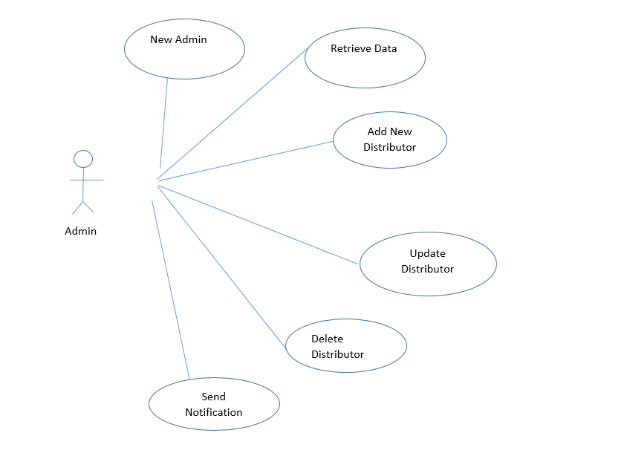

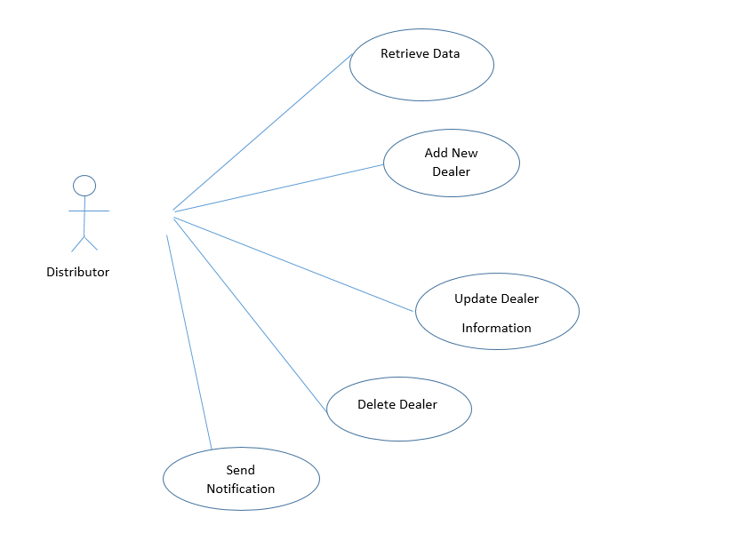

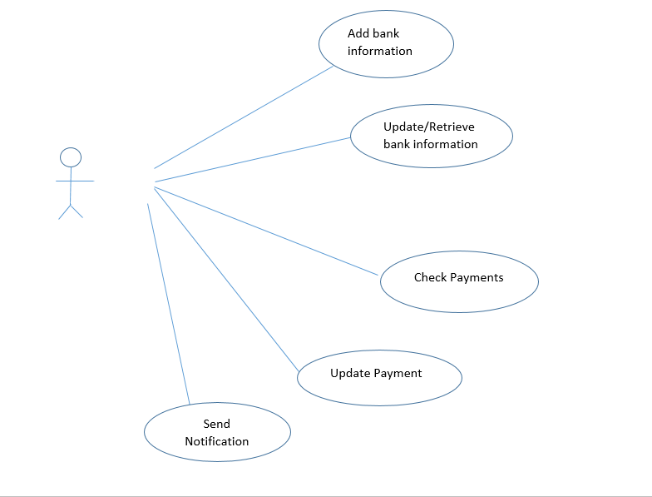

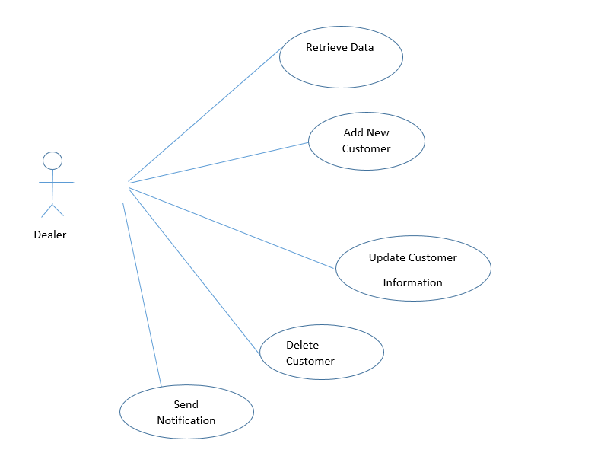

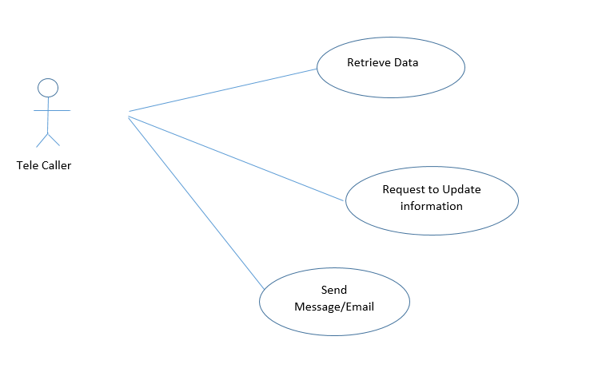

**3.3** **Usability**

**Interactive:** This system has an appealing and easy GUI which allows the user to work withthe system easily.

**Informative:** The visualization indicates changes and provides explanation at each step ofworking.

**Robustness:** The system being developed uses latest technology will be capable ofperforming continuously for 4 to 6 years with negligible cost.

**Reliability:** The system is capable of performing the required function under suitableconditions.

**Correctness:** Extensive testing of the system is carried out in order to check the correctnessof the system.

**3.4** **Performance**

There will be no restriction in time, place for the use of that product. Clients will easily check and use this software anytime, anywhere by using Mobile and other device like Computer, laptop etc. The system will be designed

**3.4.1 Capacity**

Database Can store more than thousand entries in their database.

**3.4.2** **Availability**

The software will be developed for the admins, dealers, distributors and tele Caller for Fleetomoto Company.

The software can be used anywhere, anytime no particular location will be needed to use product but only one requirement is there. user should be the part of the company then he/she can access from anywhere.

The product is developed for the Admin, Distributor and Dealer who face trouble to maintain all information manually in excel.

**3.4.3 Latency**

System is fast but sometimes it depends on user network and internet the maximum acceptable time (or average time) for a service request will be based on user requirement.

**3.5** **Manageability/Maintainability**

The product developed for future. And it is possible may be client requirement change after that or may be he develop his business. So, by putting concentration on this user can maintain this system as per his future requirement.

**3.5.1 Monitoring**

Shipping billing, personal, Accounts information (name, account name, bank name, billing all information, ship number from where it is shipping, login detail)

If the user giving wrong inputs or not giving required input, then it will show error.

**3.5.2 Maintenance**

Maintenance is inevitable in any kind of product. Most products need maintenance due to wear and tear caused by use. but Software products do not need maintenance on this count. Different people has different view related to related to software maintenance. Many people think only bad software products need maintenance. But opposite case happens in real life. Bad products are thrown away, good products are maintained and used for a long time.

Most computer programs are difficult and expensive to maintain. Software changes are poorly designed and implemented. The repair and enhancement of software often injects new bugs that must later be repaired.

The maintenance of existing software can account for over 60 percent of all effort expended by a development organization, and the percentage continues to rise as more software is produced. Much of the software we depend on today is on average 10 to 15 years old. Passwords of the user shall be encrypted in DBMS for security purposes. When the system crashes, it will return back at most one hour in maintainability purposes.

**3.5.3** **Operations**

The software is developed for any company trading, manufacturing company who sold goods to an

**3.6** **System Interface/Integration**

Database management system is required software product for coordination system because all data about system for example user and schedule information must be stored in database for later use and system functionality.

Database management system is used for that purpose and it has nice open source user interface which displays table and rows in well formatted form for developers to create and manage the whole database. The Developed Product will be supported on smartphones for all user except administration he or she will be accessing through web interface for maintaining data.

**3.7** **Security**

**3.7.1** **Protection**

All the information of the user is secure because the system use SSL (secured socket layer) and data will be encrypted.

**3.7.2 Authorization and Authentication**

The product should ensure the privacy of the user.

The login system is made with that security so that authorized users which can be anyone dealer, distributer, admin, tele caller, account can use it and update, delete, add new records and remove existing records.

**3.8 Data Management**

For data management, we are managing database also we managing online backup. Also, we are trying to back up in different system. There is a repository which known as GitHub we are going to use this to make center repository for our project, which will also going to help for backup and also provide do task on same project from different system at a time means environment of doing team project in a real organization.

**3.9** **Standards Compliance**

Our product is not certified yet but we are following all the standards which are required by companies to certify a product maybe in future based on user’s demand can be certified.

1. **User Scenarios/Use Cases**

The Fleetomoto GPS Management System has five active actors. The Admins, Distributors, Dealers, Account and Tele caller.

The Admins, Distributors, Dealers, Account and Tele caller will be accessing through web interface.

The Tele caller need to login with id and password if already register if not then with the admin permission tele caller will be added and he/she will ready to use the system.

The Admin can retrieve data and check the all report that what is the current scenario of their company that whether his company earn profit and goes under loss.

The Admin will maintain data. Updation and deletion will be also performed by Admin. Not only, admins, distributors also have right to update and delete but according to their power and authority. Some data they can delete but some not.

The Admins need to give log in authority to all distributors and tele callers then he or she can log-in and then they will able to check all their details which they add. Or some already added.

**5. DELETED OR DEFERRED REQUIREMENTS**

The system we are developing is the facilitate the interconnectivity among Admins, Distributor, Dealers, tele callers and account.

Now the user will access system through mobile as well as laptop, computer etc. Initially only Admins can add new Distributors and tele callers and data can be observe through web interface and users can use this product by their smartphone and personal computer or laptops. In future, we can add another functionality like chat module in which user can chat with one another. Initially we are going to start our project for FleetoMoto but it can be use by other organization worldwide. This project will offer interconnectivity to Admins, Dealers, Distributor, tele callers and Accounts. users it can be use by any organization.